Newton's Third Law
Introduction to Physics

Answer all questions on a separate sheet of paper.
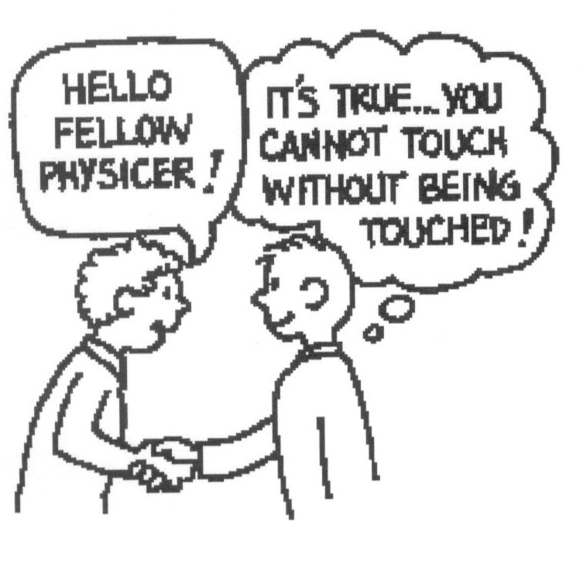
1. When a hammer interacts with a nail, which exerts a force on which?
They both exert the force on each other.

2. When a hammer exerts a force on a nail, how does the amount of force
compare to that of the nail on the hammer?
same

3. When you walk along a floor, what exactly pushes you?
The floor

4. When you jump up, does the world recoil downward? Explain.
Yes. You push it down.

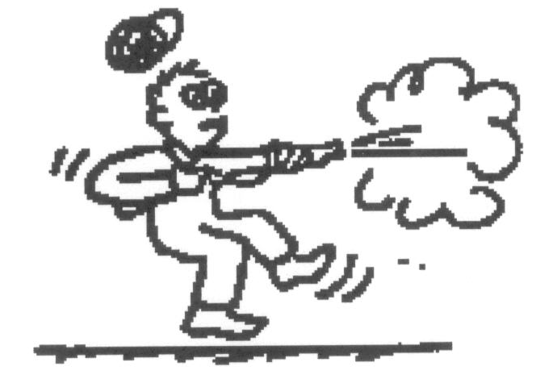
5. When a rifle is fired, how does the size of the force of the rifle on the bullet compare to the force of the bullet on the rifle?
same

- How do the accelerations of the rifle and bullet compare? Why?
Bullet’s is bigger due to smaller mass

6. Why is it easier to walk on a carpeted floor than on a smooth, polished floor?
More friction to push you.
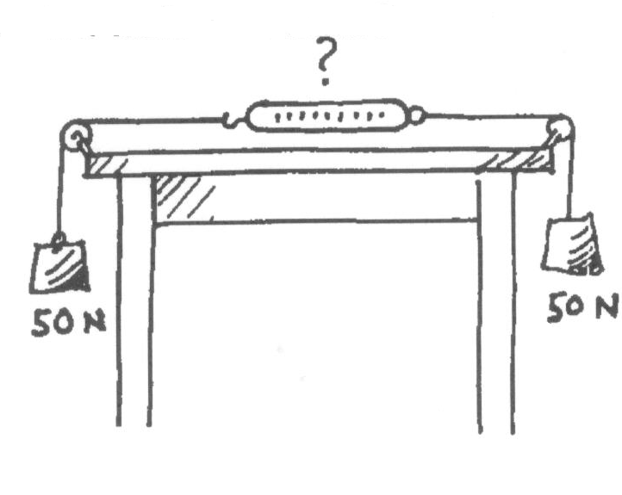

7. A pair of 50 N weights are attached to a spring scale as shown in the diagram. Does the scale read 0, 50, or 100 N?
50 N

8. If a bicycle and a massive truck have a head-on collision, upon which vehicle is the impact force greater?
same

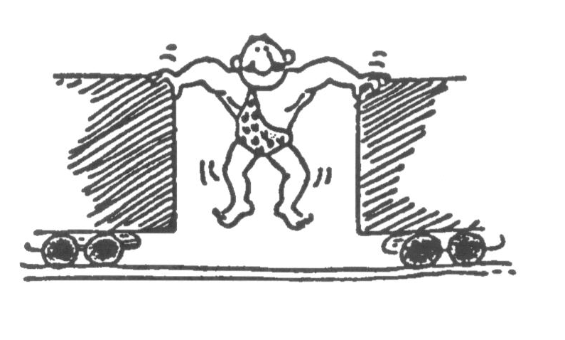
- Which vehicle undergoes the greater change in acceleration?
bicycle

9. The strongman will push the two initially stationary freight cars of equal mass apart before he himself drops to the ground. Is it possible for him to set either of the cars in greater motion than the other?
Explain!
No.

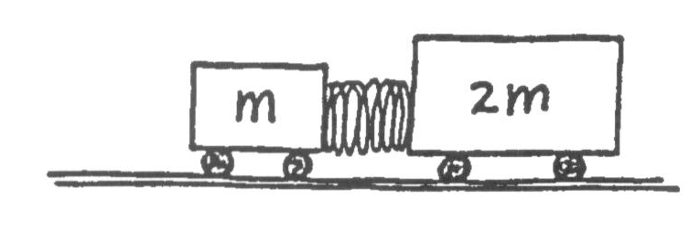
10. Suppose two carts, one twice as massive as the other, fly apart when
the compressed spring that joins them is released. How fast does the
heavier cart roll compared to the lighter cart? Explain.
far. Twice the mass equals half the acceleration and this half
the dis
tance
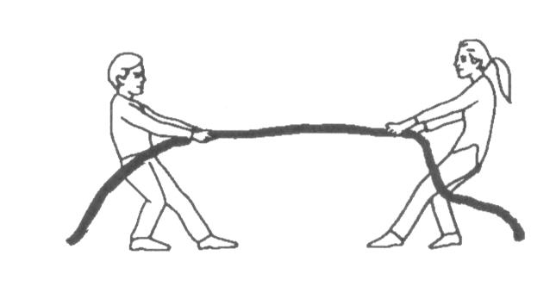
11. Two people of equal mass attempt a tug-of-war with a 12-meter rope
while standing on frictionless ice. When they pull on the rope, they each
slide toward each other. How do their accelerations compare?
Equal

- How far does each person slide before they meet?
6 m

12. Suppose in the preceding example that one person has twice the mass of the other. How far does each person slide
before they meet?
8 m & 4 m

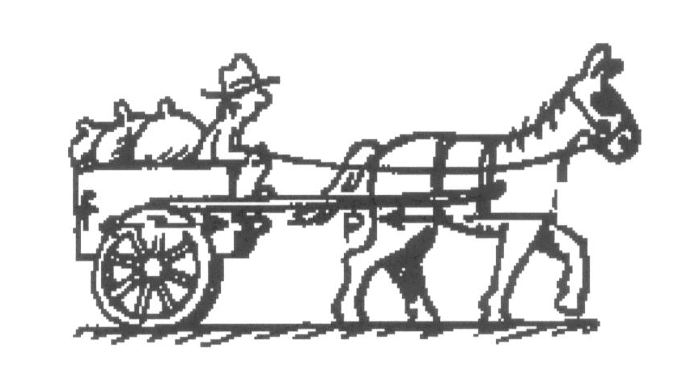
13. A horse pulls a wagon with some force, causing it to
accelerate. Newton's third law says that the wagon exerts an
equal and opposite reaction force on the horse. How can the
wagon accelerate?
The horse pushes the ground and the ground pushes back on
the horse causing it to move and thus it pulls the wagon along
with it.

Math-Based Practice
14. A semi-truck collides with a car with a force of 5000N. The semi-truck has a mass of 2000kg and the car has a mass of 500kg.
a. What was the acceleration of the truck when it hit the car?

b. What force did the car exert on the semi-truck at impact?

c. How much did the car accelerate when it was hit?

d. If the action statement is ‘The semi-truck exerts a force on the car,’ what is the reaction statement?

15. A sumo wrestler has a wrestling match with Spongebob. The sumo wrestler has a mass of 150kg and accelerates toward the midget at 5m/s². Spongebob has a mass of 30kg.

a. What force of impact does the sumo wrestler have with Spongebob?

b. What force upon impact does Spongebob have with the sumo wrestler?

c. How much does Spongebob accelerate due to the impact with the wrestler?

d. If the action statement is ‘The sumo wrestler exerts a force on Spongebob,’ what is the reaction statement?



