Effects of Heating
Introduction to Physics

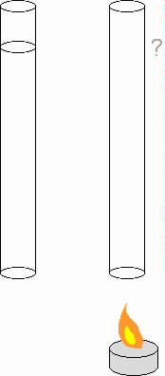

Suppose you have a tall cylinder containing some water at room temperature, as shown in the left panel.
Using a small burner, you now warm up the water until the entire tube of water is now very hot (although not boiling, and you have been careful to not allow any water to escape by evaporation).
1. Draw in the new water level in the right-hand picture.
2. How does the mass of the warm water compare with that of the room-temperature water?
3. How does the density of the hot water compare with the cold-water density?
4. How does the surface area at the bottom of the tube compare?
5. Compare the pressure at the bottom of the tubes in the two cases..

-1-
Convection
Introduction to Physics
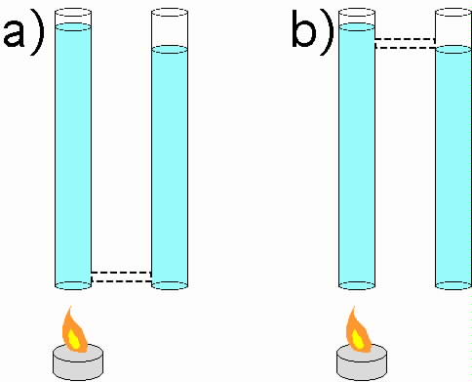
A

B

This worksheet explores the consequences of connecting two tubes using a third, small tube.
Two scenarios are shown above, cases A and B. In each of the cases, water in the left-hand tube is hot, having been heated up by the small burner. Case A suggests connecting the bottoms of the two containers using a small tube, and case B suggests using the same tube to connect the tops as shown.
1. Describe what will happen to the fluids in the two tubes if they are connected as in case A. Give your answer in terms of pressure.

2. Describe what will happen in case B, where the tubes are connected at the top. Use the same reasoning as before, casting the explanation in terms of pressure.

3. Is one of these two configurations, A or B, more efficient than the other at equalizing the two water levels? If so explain why, and if not, explain why not.

-2-
More Convection
Introduction to Physics

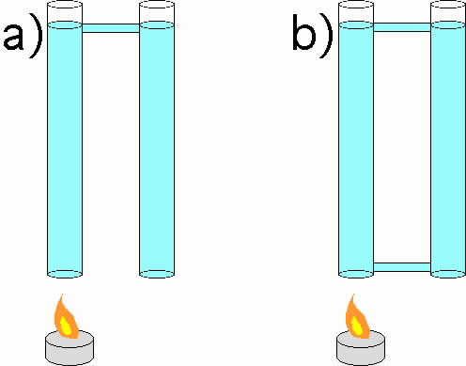
B
A

These two scenarios, A and B show two cylinders, the left one full of hot water and the right one full of room temperature water;
Case A shows the cylinders after they have been connected using a short tube near the top. The two water levels have equalized, although the water temperature in the two cylinders is still very different.
1. How does the density of the water in the two cylinders compare? Explain.
2. How does the mass, and thus the weight, of the the water in the two cylinders compare? Explain.
3. Compare the pressure at the bottom of the two cylinders. Are the pressures equal? If not, which is greater? Explain your answer, using what you know about the mass, weight and relevant areas involved.
4. Case B shows the bottoms of the cylinders now connected, as well as the tops. Predict what will happen when the bottom tube is attached as shown.
5. If there is any motion, will it die away or will it continue? Explain how this can happen.

-3-
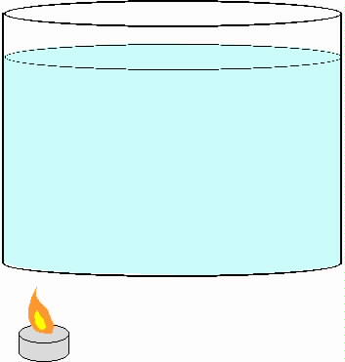

Now consider a large container of water (say, a pot on a stove), with a heat source off to one side. Use arrows to draw in the direction of motion of the water in various parts of the container.

-4-

